Mount Wilson Capita Reference Manual

**Table of Contents**

1 Select User – Employee 2

1.1 Add Employee 2

1.2 Update Employee 5

1.3 Delete Employee 9

1.4 Enter Hours Worked 11

2 Select User: Applicant 15

2.1 Loan Form 15

2.1.1 Fill out Loan Application Form 15

# Select User – Employee

This section is intended to give administrative users detailed step-by-step instructions for how to use the functions of Mount Wilson Capital Database System.

## Add Employee

1. Before going further into the system, first select what type of user you are: Applicant ot Employee

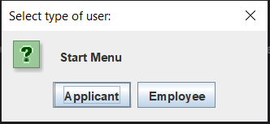

1. After selecting user Employee, Enter the username and password given to you, the click **Login**.

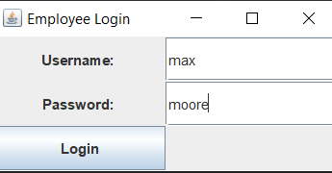

1. After logging in to the system, you will see the following page.

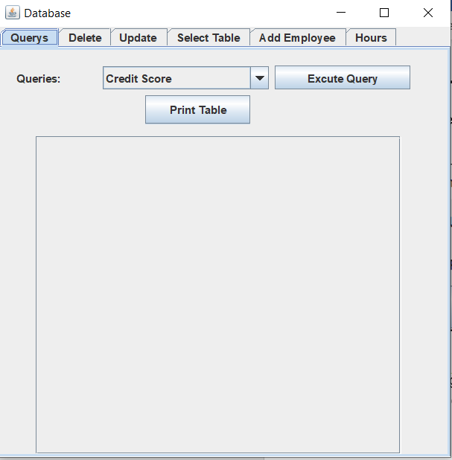

1. Click on the tab that says, “**Add Employee**”. Fill out Employee information as the form states. Click “*Add Employee*” at bottom of page.

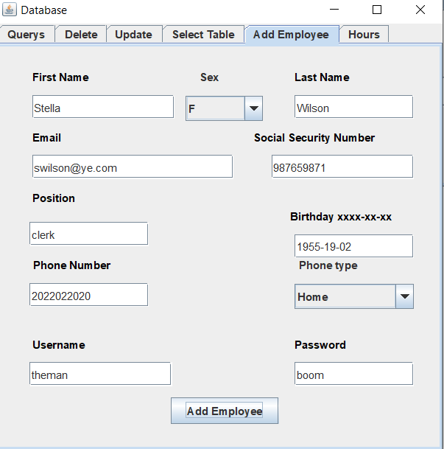

1. A prompt will pop-up seeking confirmation to add employee. Click “*Yes*” to add Employee

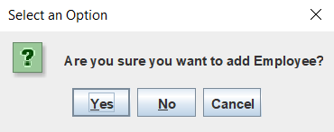

1. Go to the “**Select Table**” tab click of the drop-down menu and select “**Employee**” to verify added employee to system.

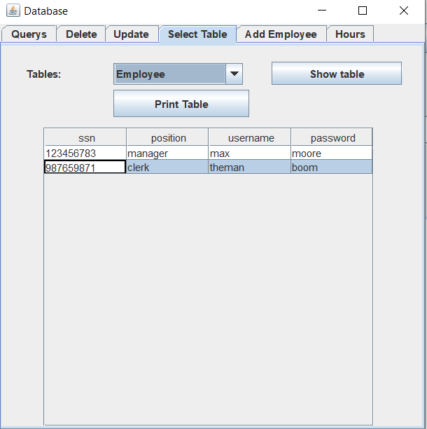

## Update Employee

1. After following log-in procedure (see 1.1 number 1 and 2), go to and click on the “**Update**” tab.

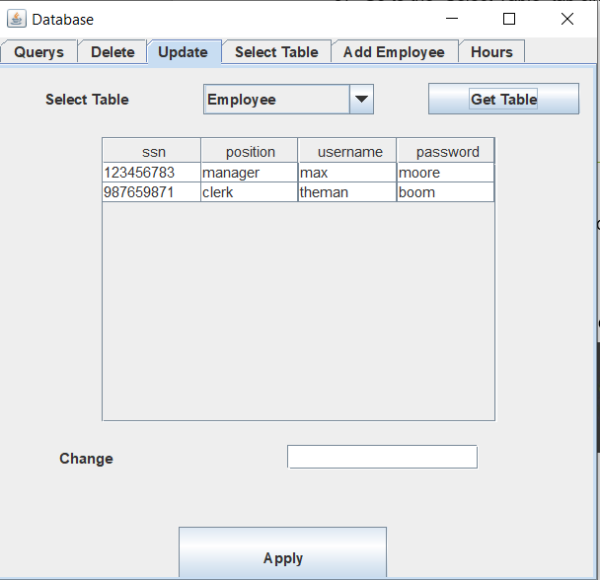

1. Click on the employee information to choose which employee you want to delete. Double-click on the field you want to get a textbox

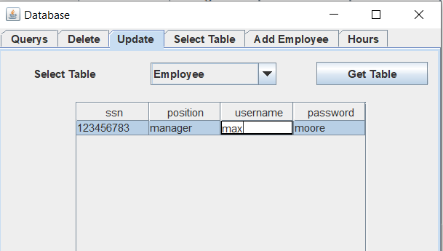

1. Delete the information in the textbox. In the textbox at the bottom, enter the new information you want to enter. For this example, will be updating the employee’s username. We will update the username from “max” to “tom. Click “*Apply*” to make updates

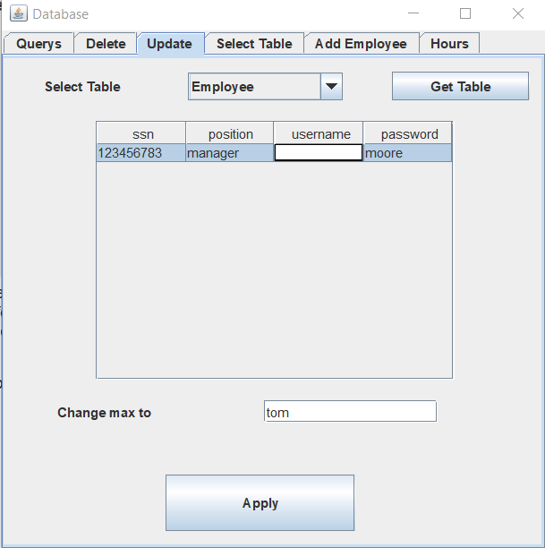

1. You will be prompted to confirm system update. Click “*Yes*” to update.

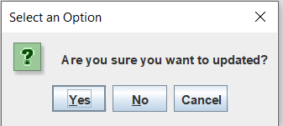

1. Check to see System update to employee information.

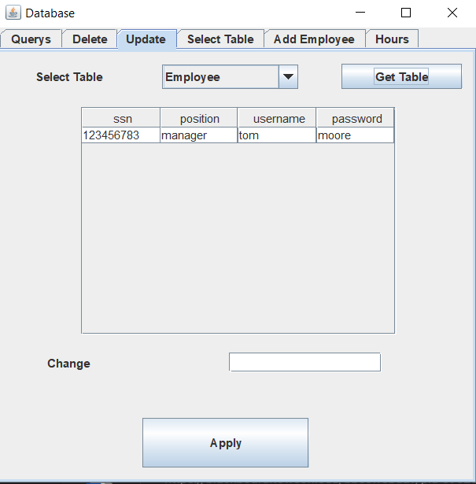

1. The update to your username is complete.

## Delete Employee

1. After following log-in procedure (see 1.1 number 1 and 2), go to and click on the “**Delete**” tab.

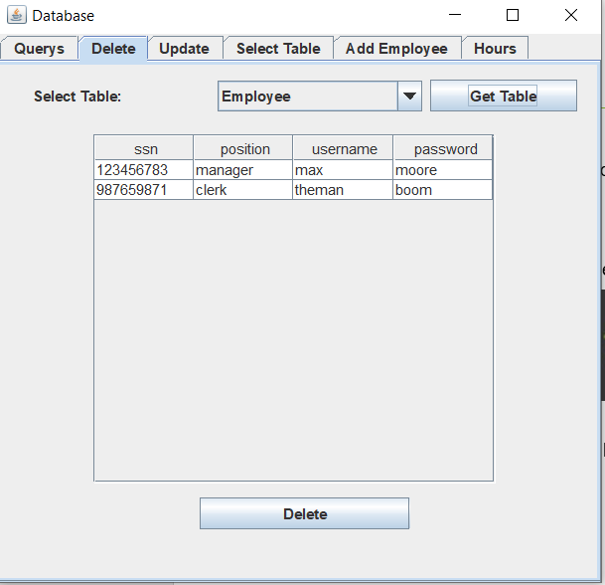

1. Select the employee you want to be deleted from the System. Click “*Delete*” at bottom of the screen.

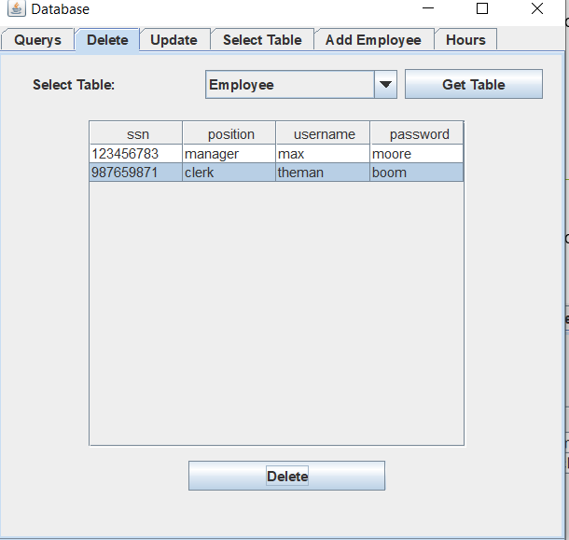

1. A prompt will pop-up seeking confirmation of deletion. Answer “*Yes*” to delete employee.

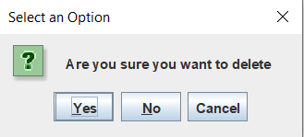

1. Employee has been deleted from database. Based on example, employee with SSN as 987659871 has been deleted.

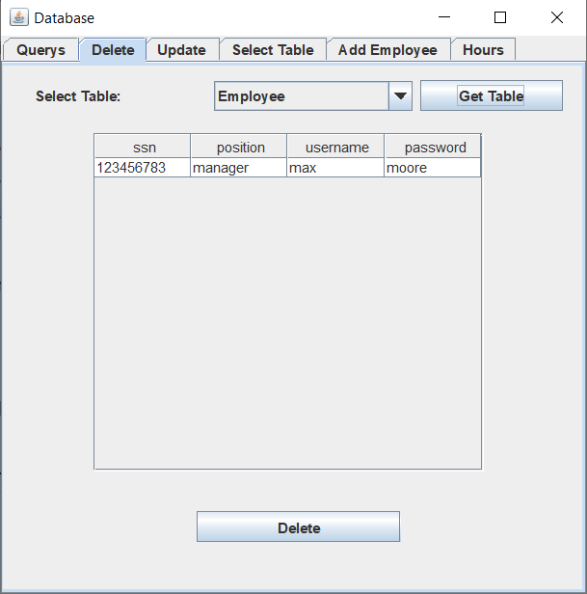

## Enter Hours Worked

1. After following log-in procedure (see 1.1 number 1 and 2), go to and click on the “**Hours**” tab.

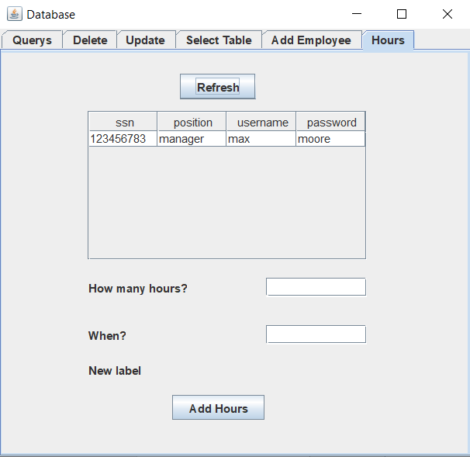

1. Select the Employee you want to enter hours for. Enter their hours worker, and the date in which said hours were worked in YYYY-DD-MM format

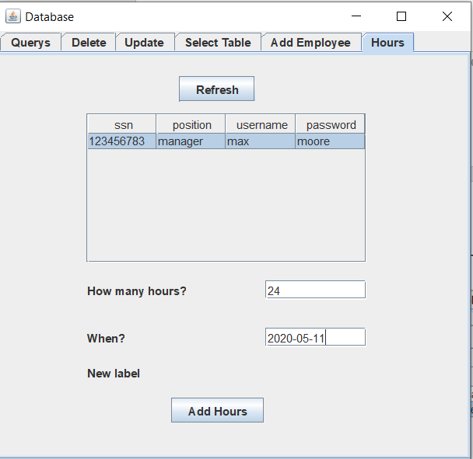

1. Click “*Add Hours*”. A prompt will pop-up seeking confirmation to add hours. Answer “*Yes*” to enter employee hours

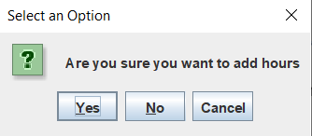

1. Go to the “**Select Table**” tab click of the drop-down menu and select “Hours” to verify hours added for employee.

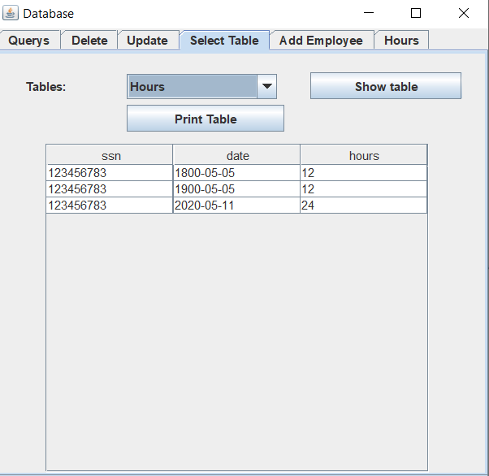

# Select User: Applicant

This section is intended to give applicant users detailed step-by-step instructions for how to use the functions of the Mount Wilson Capital System

## Loan Form

### Fill out Loan Application Form

1. Before going further into the system, first select what type of user you are: Applicant or Employee. In this case we will be selecting “Applicant”



1. You will see the following page after selecting type of user

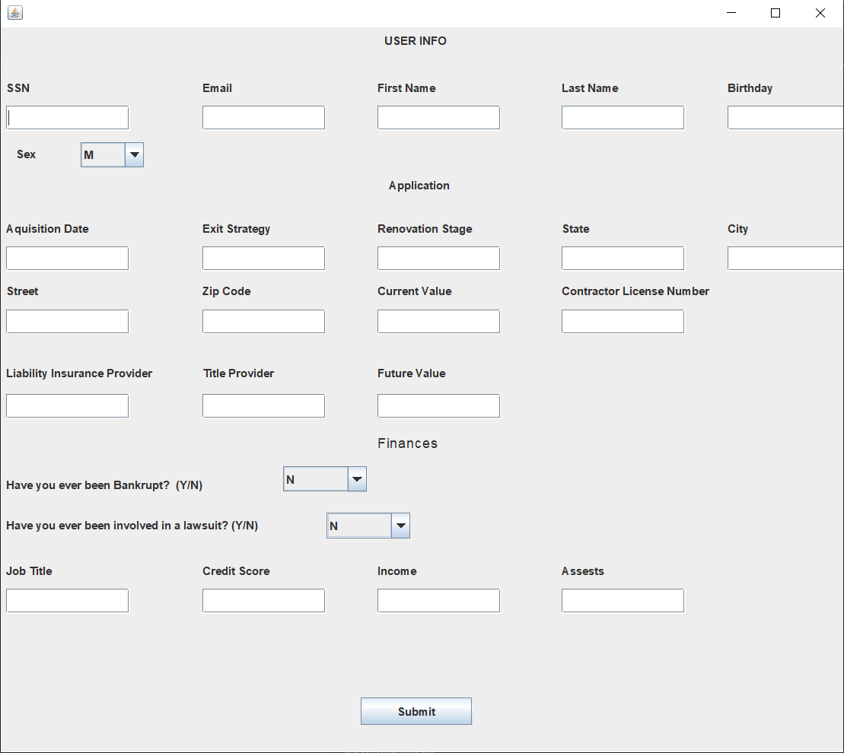

1. Fill out loan application form as stated

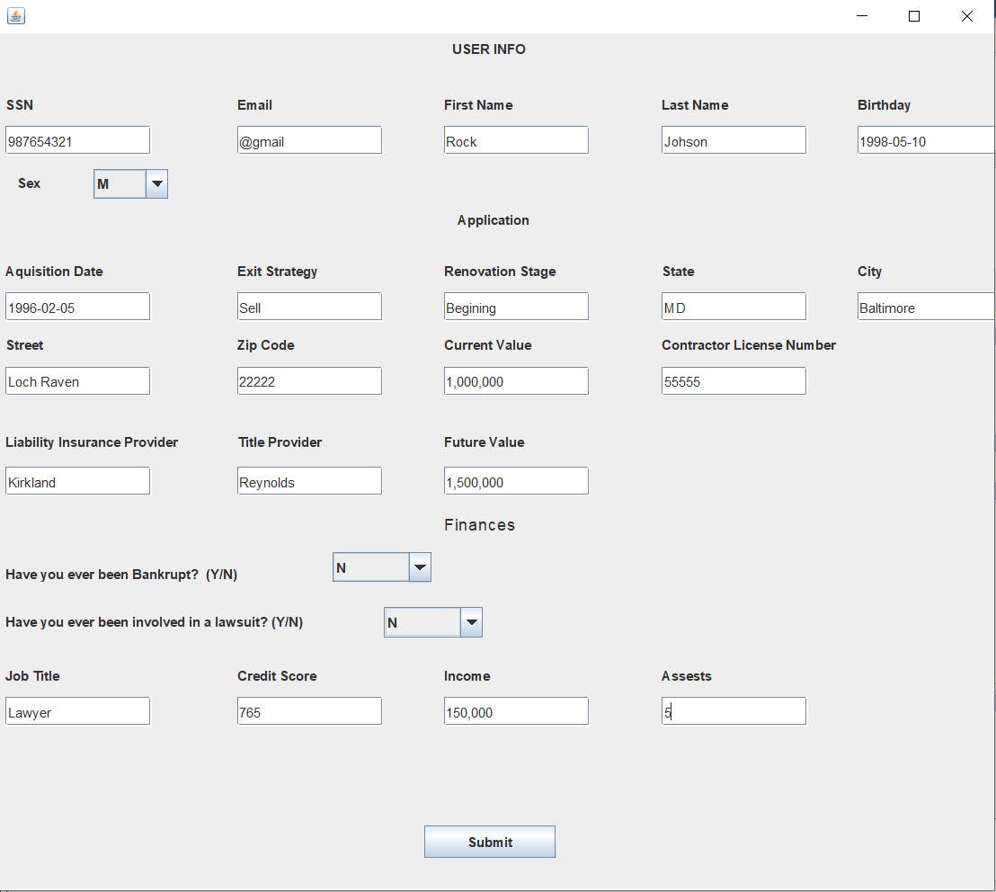

1. Click “*Submit*” to send in your form



1. You will be prompted to confirm submission of form. Click “*Yes*”. After clicking on “Yes,” form has been submitted.

